**Refresher- Week 2: Electric Potential and Capacitor**

1. **Electric Potential (Voltage) due to a continuous charge distribution:**

**Method 1:**

The potential (**dV**) at a point of interest (**P**) due to a point of charge **dq** verifies :



To find the total potential, calculate the below integral to include the contributions from all the points of the continuous charge distribution:



**T**his *V* expression uses the reference of *V* = 0 when the point of reference is infinitely far away from the charge distributions.

**Method 2:**

If the electric field (E) is already known from other considerations such as Gauss’s Law, the potential can be calculated using:



Where $\vec{ds}$ is the displacement vector tangent to a path of a charge moving between points A and B .

**Special cases:**

**Case 1: Uniform Electric field** (the electric field is constant in magnitude and direction):



**.**

**If $\vec{s}$ is a straight path, $∆V=-E.S.cos\left(θ\right)=-E.d$**, see below figure.

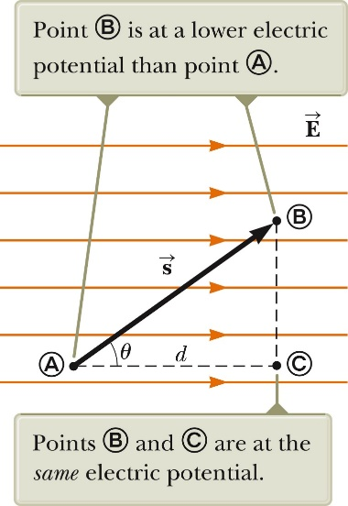

The plane (BC) is equipotential.

If $\vec{s}$ is parallel to $\vec{E}$ and on the same direction:

$$∆V=-E.d$$

**Case 2: Radial Electric Field**

If the Electric Field is directly radially, $∆V=$**- $\int_{A}^{B}{E_{r}*dr}$**

For the figure below $E_{r}=k_{e}\frac{q}{r^{2}}$

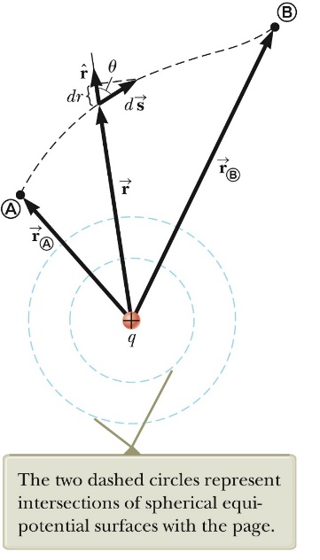

1. **Electrostatic force is a conservative force.**

According to the energy conservation law:

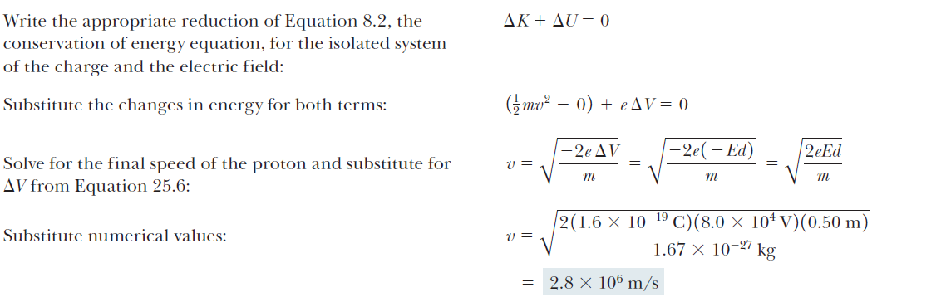

Where ∆K is the difference in Kinetic Energy between points A and B: KB-KA, and ∆U is the difference of potential energy: UB-UA

K = $\frac{1}{2}mv^{2}$, where m is the mass of the moving particle and V is its speed at the point of interest.

∆U= q. ∆V, where q is the charge of the moving particle and ∆V is the electric potential difference between points A and B.

1. A battery gives a steady electric potential across its terminals over a relatively long time compared to a capacitor which discharges much quickly.
2. The space between the capacitor plates is filled with an insulator.
3. The capacitance, *C*, of a capacitor is defined as the ratio of the magnitude of the charge on either of the capacitor conductors/plates to the potential difference between the plates:



For any capacitor, C is (theoretically) constant; Q and ∆V are not.

* After connecting two uncharged capacitors in series to a Battery andat the equilibrium of the charges transfer, the two capacitors get the same charge Q. This can be considered as the charge of the equivalent capacitor (the left plate of C1 and right plate of C2). Then,

**Q1 = Q2 = Q**



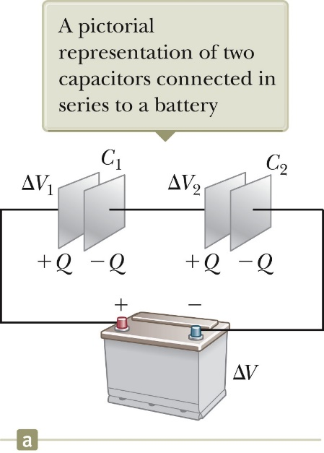

* After connecting two uncharged capacitors in parallel to a Battery and at the equilibrium of the charges transfer, the voltages across the capacitors are equal to the that of the battery; however, their respective charges are not necessarily equal:

Q1 + Q2 = Qeq

∆V1 = ∆V2 = ∆V

which leads to ,

*C*eq = *C*1 + *C*2

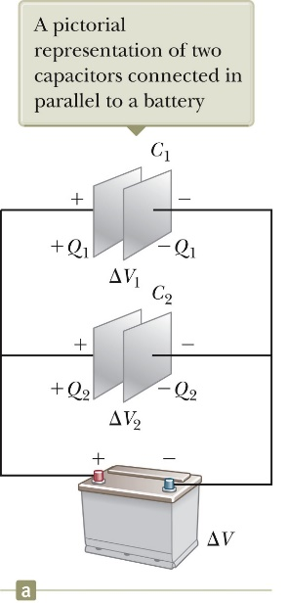

* If you connect directly **a fully charged capacitor to a partially charged capacitor.** The two capacitors will be in parallel.

**Case 1:** connect the respective like-sign plates to each other, i.e., positive plate to positive’s, negative plate to negative’s.

At the connection, the number of the initial charges at each capacitor plate verifies:



Therefore, we can deduce the total of like-sign charges (Qtotal) at each pair of plates. This number of charges get distributed over the two plates such that at the equilibrium we have:

∆V1 = ∆V2= ∆V

where , C1=Q1/∆V , C2=Q2/∆V, and Q1+Q2=Qtotal

**Case 2:** connect the respective unlike-sign plates to each other, i.e., positive plate to negative.

At the connection, the number of the initial charges at each capacitor plate verifies:



Equal number of negative and positive charges at each pair of plates cancel each other; the residue of charges (Qdifference) gets then distributed on the two plates such that at the equilibrium we have : ∆V1 = ∆V2= ∆V

Where, C1=Q1/∆V , C2=Q2/∆V, and Q1+Q2=Qdifference